**TYPE:** Test

**TASK 5: Circulatory and Gas Exchange Test (85 marks)**

Students will complete a number of questions relating to circulation and gas exchange. These questions will address specific content as well as analysis of second hand data. This task will be completed in one session under test conditions.

**Time for the tasks (1 hour)**

* 5 minutes reading time
* 55 minutes working time

**What you need to do:**

* Follow the instructions provided very carefully to complete the test
* Draw any results in pencil and answer all questions given.
* It is your responsibility to organise your time effectively.
* There is to be no discussion between you or any of your class mates.
* No sharing of any equipment or answers at all.

|  |  |
| --- | --- |
| **Requirements for assessment** | **Due dates:** |
| x Complete all questions | _**__________________** |

|  |  |  |  |
| --- | --- | --- | --- |
| Part | Section | Marks Available | Your Mark |
| A | Multiple Choice | 25 |  |
| B | Terminology | 10 |  |
| C | Short Answer | 38 |  |
| D | Extended Response | 12 |  |
|  | TOTAL | 85 |  |

**DO NOT TURN THIS PAGE OVER UNTIL YOU ARE TOLD TO**

**STUDENT NAME: __________________________________________________________________**

**TEACHER: Mrs Cunningham YEAR: 11**

**Circulatory and Gas Exchange Test**

**PART A: Multiple choice questions.**

**Please mark your answers in the answer section provided and NOT on the questions.**

1. All exchanges of fluid, nutrients and wastes between the blood and the tissues occurs across the walls of
2. the heart
3. lymph ducts
4. veins
5. capillaries
6. Which of the following statements is FALSE concerning the right atrium?
7. it receives venous blood through three openings
8. when it contracts it empties into the ventricle across the atrioventricular valve
9. it receives blood from the body
10. it is the thickest part of the heart
11. Which of the following are involved in pulmonary circulation?
12. right ventricle, pulmonary trunk, left atrium
13. superior vena cava, right atrium, right ventricle
14. left ventricle, aorta, pulmonary trunk
15. right atrium, right ventricle, left atrium
16. Closing of the atrioventricular valves produces
17. the first heart sound (lubb)
18. the second heart sound (dub)
19. both of the heart sounds
20. neither of the heart sounds
21. The diagram below represents a section of an alveolus and a capillary that surrounds it.

**Y**

**X**

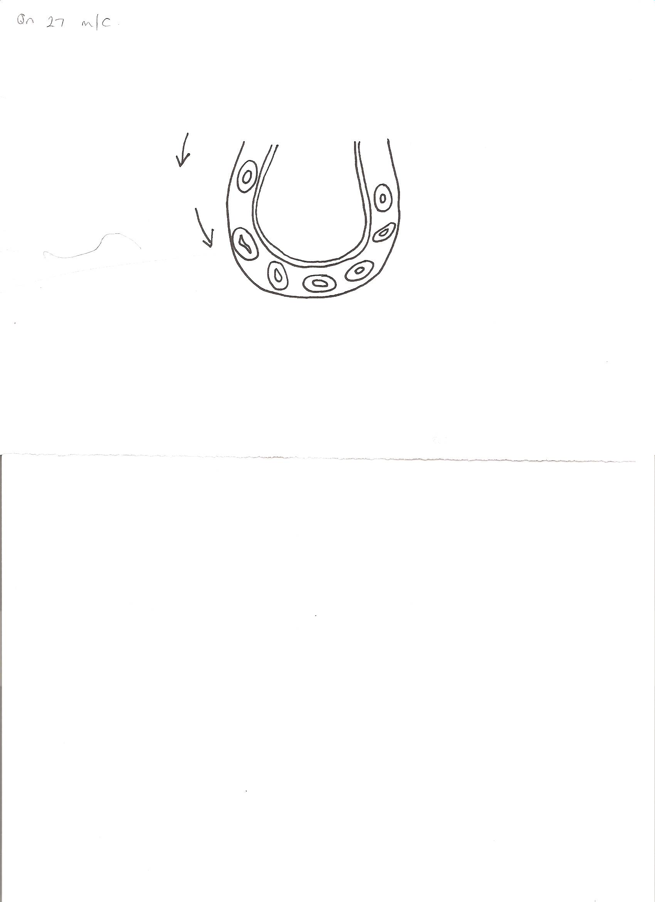

**capillary walls**

**direction of flow**

**of blood**

**AIR**

**red blood cells**

**alveolar wall**

As the blood moves from X to Y it:

1. gains oxygen and becomes darker red
2. loses oxygen and becomes brighter red
3. gains oxygen and becomes brighter red
4. loses oxygen and becomes darker red
5. Carbon dioxide is carried in the blood mainly by the:
6. lymph
7. red blood cells
8. white blood cells
9. plasma
10. One function of platelets is to
11. assist in the clotting of blood
12. carry haemoglobin
13. ingest bacteria
14. transport carbon dioxide
15. Erythrocytes mainly carry:
16. oxygen
17. carbon dioxide
18. oxygen and carbon dioxide
19. oxygen and nitrogen

9. White blood cells can be distinguished from red blood cells because they:

1. have a bi-concave shape
2. have a nucleus
3. contain haemoglobin
4. move in groups

10. The presence of valves between the chambers of the heart ensures:

1. blood is maintained at a constant pressure
2. blood can move directly into the aorta
3. blood flow is restricted to one direction
4. all chambers of the heart can fill with blood simultaneously

11. During the cardiac cycle the following events take place:

1. atrial systole
2. diastole
3. ventricular systole

In which order do the events occur?

1. atrial systole, diastole, ventricular systole
2. diastole, ventricular systole, diastole
3. atrial systole, ventricular systole, diastole
4. ventricular systole, atrial systole, diastole

12. In which of the following blood vessels would you expect blood pressure to be the highest?

1. vena cava
2. aorta
3. pulmonary artery
4. pulmonary vein

13. The strong tendinous cords attached to the atrioventricular valves and the heart wall

1. strengthen the septum
2. support the pericardium surrounding the heart
3. prevent the valves from turning inside out
4. slow down the flow of blood through the heart

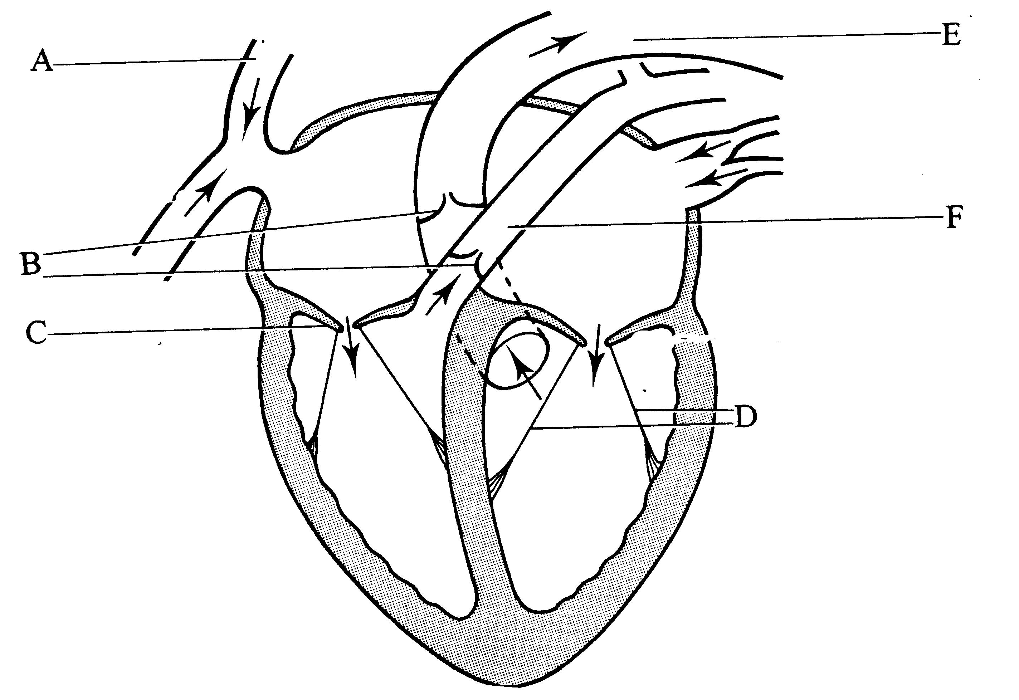

14. The part of the heart labelled A is the

1. aorta
2. superior vena cave
3. semi lunar valve
4. left atrium

15. What is the function of the structure labelled F?

1. to carry blood from the body into the right atrium
2. to carry blood from the right ventricle to the lungs
3. to carry blood from the lungs to the right ventricle
4. to carry blood from the body into the left atrium

16. Which type of blood cell plays an important role in the cessation of bleeding or clotting?

1. leukocytes
2. erythrocytes
3. platelets
4. granulocytes

17. The liquid part of the blood is called

1. platelets
2. plasma
3. cytoplasm
4. haemoglobin

18. The three types of cells found in blood are

1. thrombocytes, platelets, plasma
2. erythrocytes, leukocytes, plasma
3. erythrocytes, thrombocytes, leukocytes
4. plasma, platelets, leukocytes

19. The pigment that is present in red blood cells is called

(a) haemoglobin

(b) plasma

(c) lymph

(d) antibodies

20. During inspiration air moves into the lungs. This happens when

1. there is downward movement of the diaphragm and an upward movement of the ribs
2. the outer intercostal and diaphragm muscle relaxes
3. the internal volume of the thoracic cavity decreases
4. the internal pressure of the thoracic cavity increases

21. Which of the following is true of gaseous exchange through the wall of the alveoli?

1. diffusion of carbon dioxide occurs at the same rate in both directions
2. diffusion of oxygen occurs at the same rate in both directions
3. diffusion of oxygen is from alveoli to the blood capillaries
4. diffusion of carbon dioxide is from the alveoli to the blood capillaries

22. The flap of tissue that covers the trachea during swallowing is called the

1. glottis
2. epiglottis
3. peristalsis
4. larynx

23. The main reason for having millions of alveoli in the lungs is to

1. fill in an empty space
2. allow a lot of blood flow to the lungs
3. increase the surface area of the lungs
4. allow air to reach the bloodstream

24. The main function of the nasal cavity is

1. warm and filter air
2. act as a resonating chamber for sound
3. provide a surface for detecting odours
4. supply mucus

25. The subdivisions of the bronchi are called

1. alveoli
2. bronchioles
3. cartilage
4. trachea

**END OF MULTIPLE CHOICE QUESTION SECTION**

**PART B – TERMINOLOGY (10 marks)**

**Write the most appropriate term in column 2, for the statements in column 1**

|  |  |  |
| --- | --- | --- |
|  | **Column 1** | **Column 2** |
| **1.** | The dome-shaped muscle that separates the abdominal cavity from the thoracic cavity |  |
| **2.** | The membrane which completely encloses and protects the heart is called the |  |
| **3.** | Erythrocytes have a relatively short life span because they lack a |  |
| **4.** | When heart muscles contract |  |
| **5.** | Most of the carbon dioxide which travels in the blood plasma does so in the form of: |  |
| **6.** | The trachea is prevented from collapsing by rings of |  |
| **7.** | The non-liquid part of blood |  |
| **8.** | The muscles between ribs which assist with inhalation and exhalation. |  |
| **9.** | Excess fluid returned to the blood by the lymphatic system |  |
| **10.** | The two layered membrane covering each lung. |  |

**PART C: Short Answer questions. (38 marks)**

**Please write your answers in the spaces provided on this sheet.**

1. Use this diagram of the heart to answer the following questions:

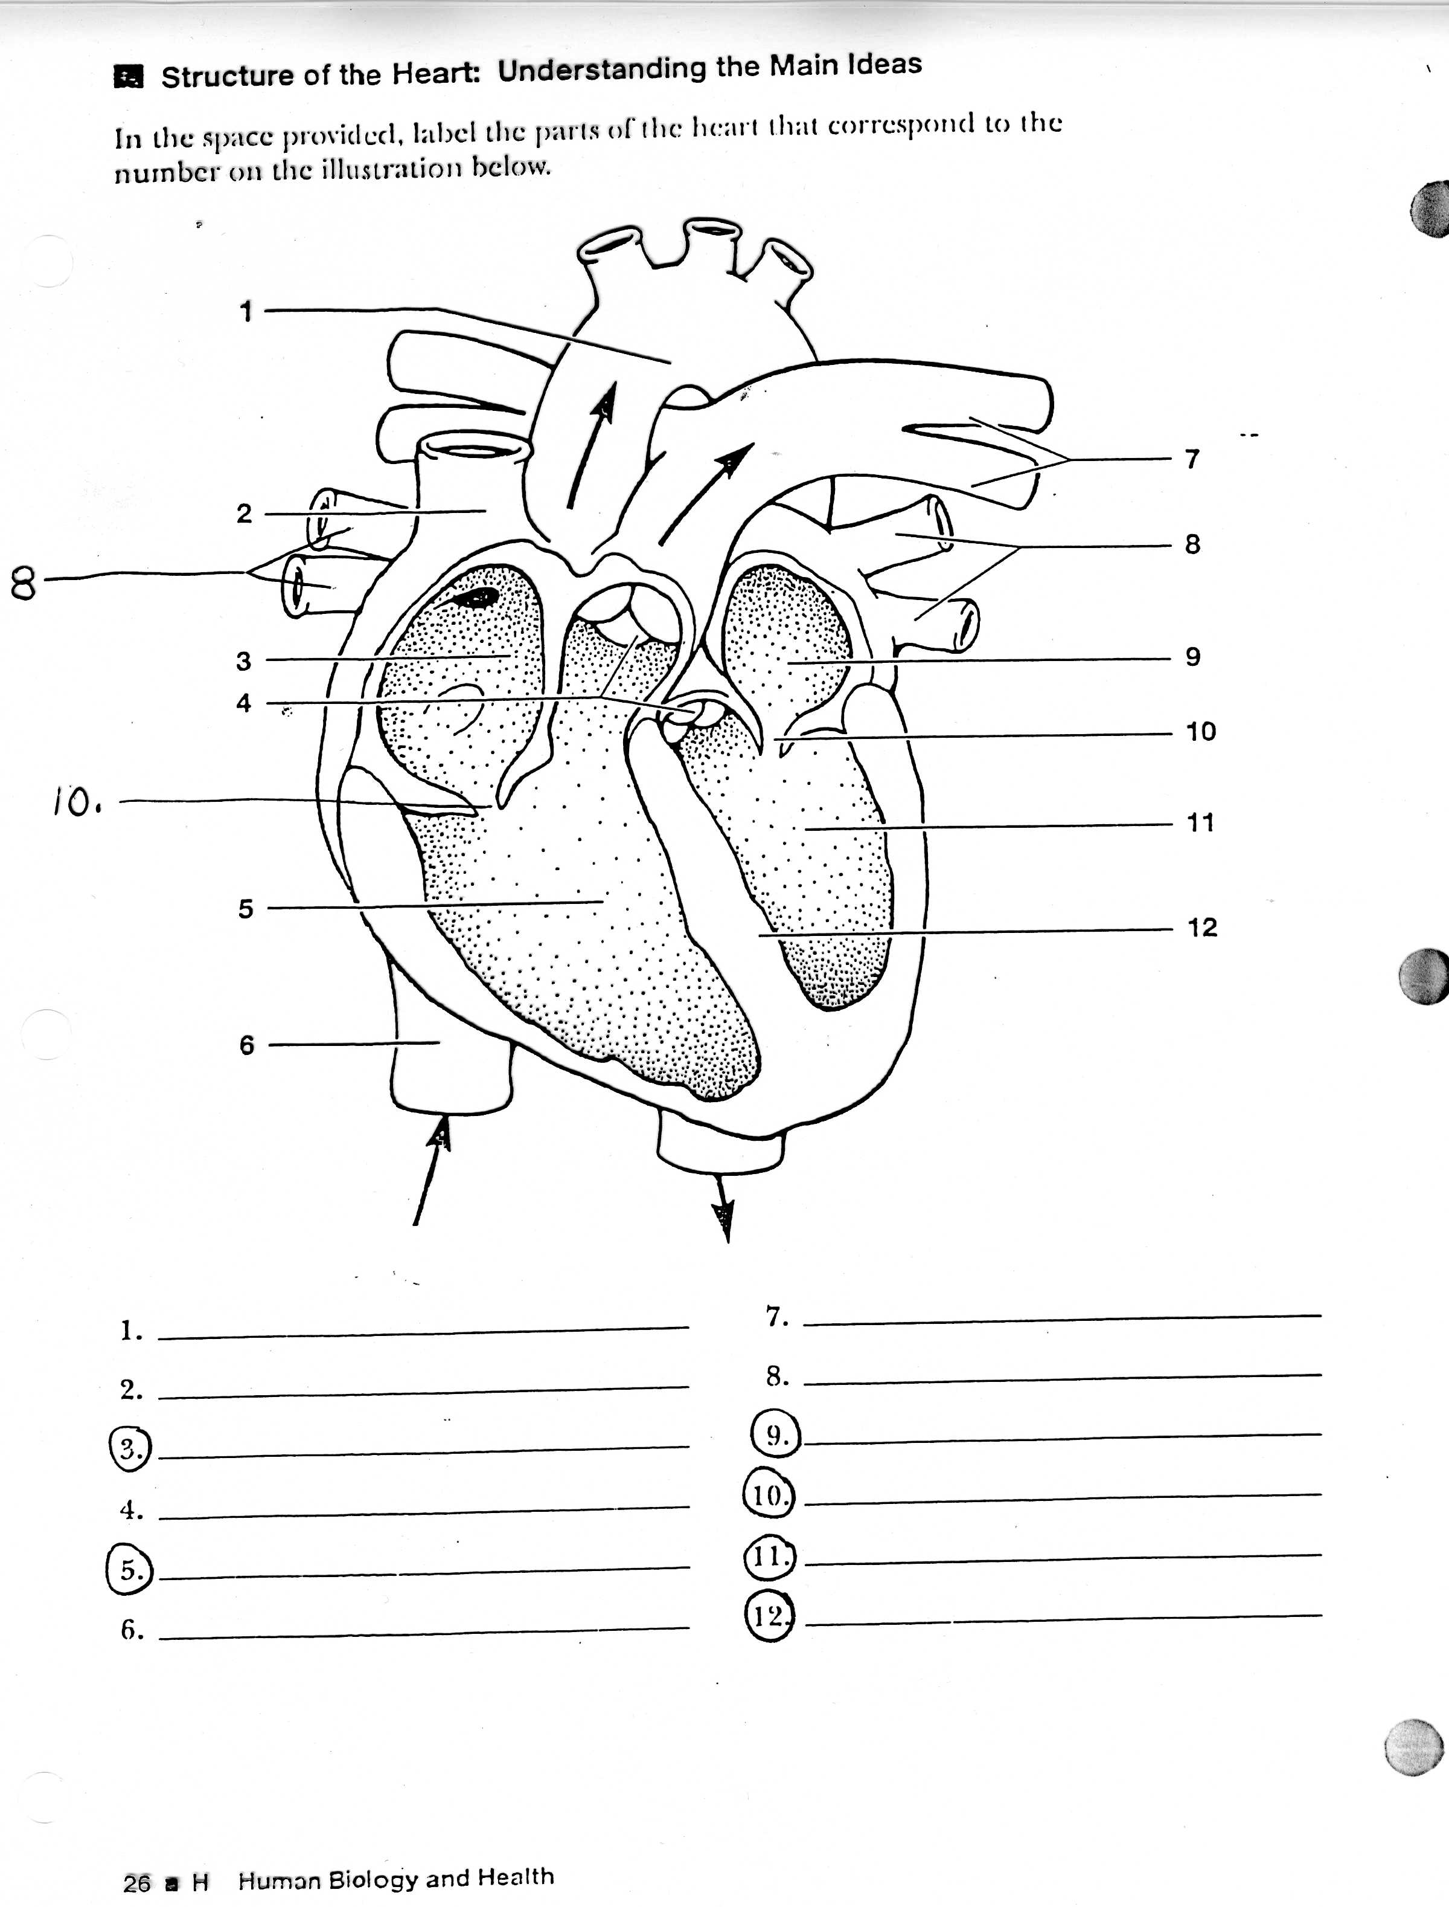

(a.) Name structure 10 _________________________________________________________

and structure 4 __________________________________________________________

[2 marks]

(b) Explain the function they have in common.____________________________________-

___________________________________________________________________________________________________________________________________________________________________________________________________________________________________________________________________________________________________________________________________________[3 marks]

(c) Which chamber of the heart does the greatest work? Give evidence to support your answer?

________________________________________________________________________________________ ________________________________________________________________________________________

_____________________________________________________________________________

[3 Marks]

(d) Which ventricle pumps the greatest volume of blood per minute? Explain your answer.

_____________________________________________________________________________________

_____________________________________________________________________________________

____________________________________________________________________________________

[2 Marks]

(e) Label the following structures

1. 7 __________________________
2. 12 __________________________
3. 6 __________________________

[3 Marks]

2. Why might a doctor feel your lymph nodes if you are not feeling well?

_____________________________________________________________________________________

_____________________________________________________________________________________

_____________________________________________________________________________________

[2 Marks]

3. Show working for all calculations in this question.

**Cardiac Output (CO) = Heart Rate (HR) x Stroke Volume (SV)**

(a) If Jenny has a resting heart rate of 68 beats per minute and a stroke volume of 70mL, calculate her cardiac output. (3 marks)

(b) Jenny now goes for a jog around the park. Her heart rate increases to 85 beats per minute and stroke volume increases to 75mL.

(i) What is Jenny’s cardiac output now? (2 marks)

(ii) What is the percentage increase of her cardiac output while jogging?

(3 marks)

(c) Why would Jenny need to increase her cardiac output while jogging? (4 marks)

3. The diagrams below show a vein, an artery and a capillary.

Y

X

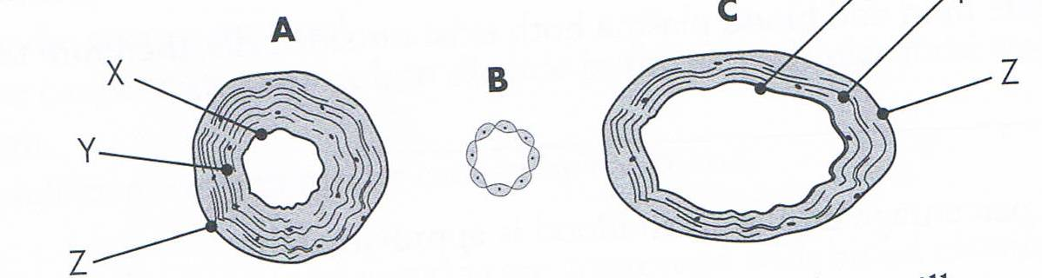

**C**

(a) Which of A, B and C is the

(i) vein _____________________

(ii) artery _____________________

(iii) capillary _____________________

[3 Marks]

(b) Name the tissues shown at

(i) X _____________________

(ii) Y _____________________

(iii) Z _____________________ [3 marks]

(c) Explain why each of the following has a different structure;

(i) vein ______________________________________________________________________

______________________________________________________________________

(ii) artery ______________________________________________________________________

______________________________________________________________________

(iii) capillary ______________________________________________________________________

______________________________________________________________________

[3 Marks]

5. Describe, in steps, what causes air to be drawn into the lungs (i.e. inspiration).

_____________________________________________________________________________________________________________________________________________________________________________________________________________________________________________

______________________________________________________________________________________________________________________________________________________________

[2 Marks]

**PART C: Extended Answer Question**

**Please write your answer in the space provided on this sheet. 12 Marks**

1. Cellular respiration depends on the delivery of glucose and oxygen to the cells. Oxygen enters the lungs, moves to the alveoli, then to the blood stream and finally to the cells where it drops off the oxygen.

**Using dot points**, explain the structures and processes which make the lungs well suited to their gas exchange function. Include in your answer a description of the gas exchange process at the alveoli surfaces.

_______________________________________________________________________________________________________________________________________________________________________________________________________________________________________________________________________________________________________________________________________________________________________________________________________________________________________________________________________________________________________________________________________________________________________________________________________________________________________________________________________________________________________________________________________________________________________________________________________________________________________________________________________________________________________________________________________________________________________________________________________________________________________________________________________________________________________________________________________________________________________________________________________________________________________________________________________________________________________________________________________________________________________________________________________________________________________________________________________________________________________________________________________________________________________________________________________________________________________________________________________________________________________________________________________________________________________________________________________________________________________________________________________________________________________________________________________________________________________________________________________________________________________________________________________________________________________________________________________________________________________________________________________________________________________________________________________________________________________________________________________________________________________________________________________________________________________________________________________________________________________________________________________________________________________________________________________________________________________________________________________________________________________________________________________________________________________________________________________________________________________________________________________________________________________________________________________________________________________________________________________________________________________________________________________________________________________________________________________________________________________________________________________________________________________________________________________________________________________________________________________________________________________________________________________________________________________________________________________________________________________________________________________________________________________________________________________________________________________________________________________________________________________________________________________________________________________________________________________________________________________________________________________________________________________________________________________________________________________________________________________________________________________________________________________________________________________________________________________________________________________________________________________________________________________________________________________________________________________________________________________________________________________________________________________________________________________________________________________________________________________________________________________________________________________________________________________________________________________________________________________________________________________________________________________________________________________________________________________________________________________________________________________________________________________________________________________________________________________________________________________________________________________________________________________________________________________________________________________________________________________________________________________________________________________________________________________________________________________________________________________________________________________________________________________________________________________________________________________________________________________________________________________________________________________________________________________________________________________________________________________________________________________________________________________________________________________________________________________________________________________________________________________________________________________________________________________________________________________________________________________________________________________________________________________________________________________________________________________________________________________________

**END OF TEST**